Week 2 Labs - Troubleshoot IPv4 and IPv6 Addressing Issues
Topology
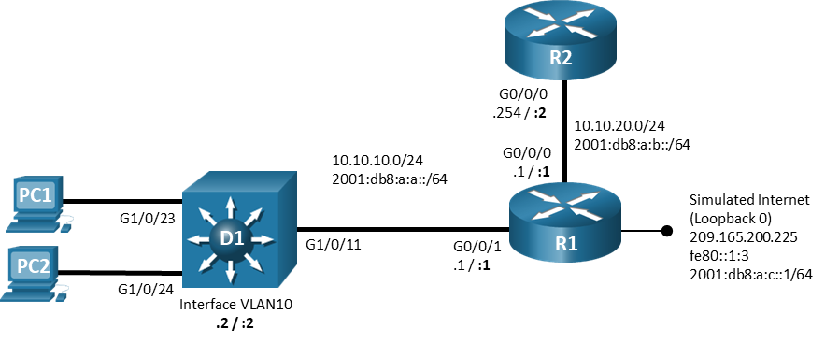
Addressing Table

Device | Interface | IPv4 Address/Mask | IPv6 Address/Prefix | IPv6 Link Local
R1 | G0/0/0 | 10.10.20.1/24 | 2001:db8:a:b::1/64 | fe80::1:1
R1 | G0/0/1 | 10.10.10.1/24 | 2001:db8:a:a::1/64 | fe80::1:2
R1 | Lo0 | 209.165.200.225/29 | 2001:db8:a:c::1/64 | fe80::1:3
R2 | G0/0/0 | 10.10.20.254/24 | 2001:db8:a:b::1/64 | fe80::2:1
D1 | VLAN 10 | 10.10.10.2/24 | 2001:db8:a:a::2/64 | fe80::d1:1
PC1 | NIC | DHCP | SLAAC | EUI-64
PC2 | NIC | DHCP | SLAAC | EUI-64
Objectives
Troubleshoot network issues related to IPv4 Addressing - DHCP.
Background / Scenario

In this topology, router R1 provides connectivity to a simulated internet for VLAN 10.
R2 serves as a DHCP server. Switch D1 provides connectivity for VLAN 10. Configurations have already been loaded to the devices with errors.

Your tasks are to FIND the error(s), document your findings and the command(s) or method(s) used to fix them. FIX the issue(s) presented here and then test the network to ensure both of the following conditions are met:
- the complaint received in the ticket is resolved
- full reachability is restored
- You have documented your troubleshooting process on Moodle and given your unique code once the file has been completed to 100%.
- You must log into each activity file using your name and student number. You cannot log in using a Guest account. Sample shown below. If you share your file with another student, the file will reset if the profile is changed. There will also be a new code if the activity is resets.

Instructions

Trouble Ticket 2 - DHCP
Scenario:
PC1 and PC2 are unable to lease IPv4 addresses from the DHCP server.
PC1 and PC2 should be configured for and receive an address from an IPv4 DHCP server.
Passwords on all devices are cisco12345. If a username is required, use admin.

